**Technical Documentation**

Open-source technology means that **its source code is freely available to use, modify, and redistribute**

**Open-Source Tool used:** <https://saltcorn.com/>

**Use case Or Idea** – Hospital management

In This use case, one stop to provide the services to the people who would want to book an appointment with the respective hospital in the nearby location or book an ambulance as an emergency service, pre-book for diagnosis and so on.

Technically how can we achieve the above idea into reality? saltcorn open- Source tool helps us to develop an application as easy as possible. 3 important things to consider for development is designing the UI, create tables and build relationships between tables and API calls or a service creation.

**UI-Design**

Using **SaltCorn,** you can create easy, rich and responsive UI’s a small image below shows the components you can use to create the UI 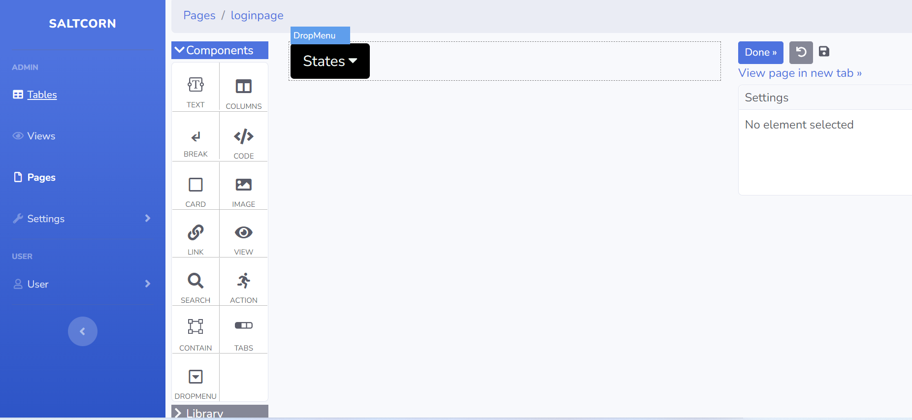

In the above image, we can see the left pane, clicking on Pages, you can create your own page upon that you have components where you can add them based on the requirements.

Here there is an option to code, where you can include html, CSS or JS code like below fig.

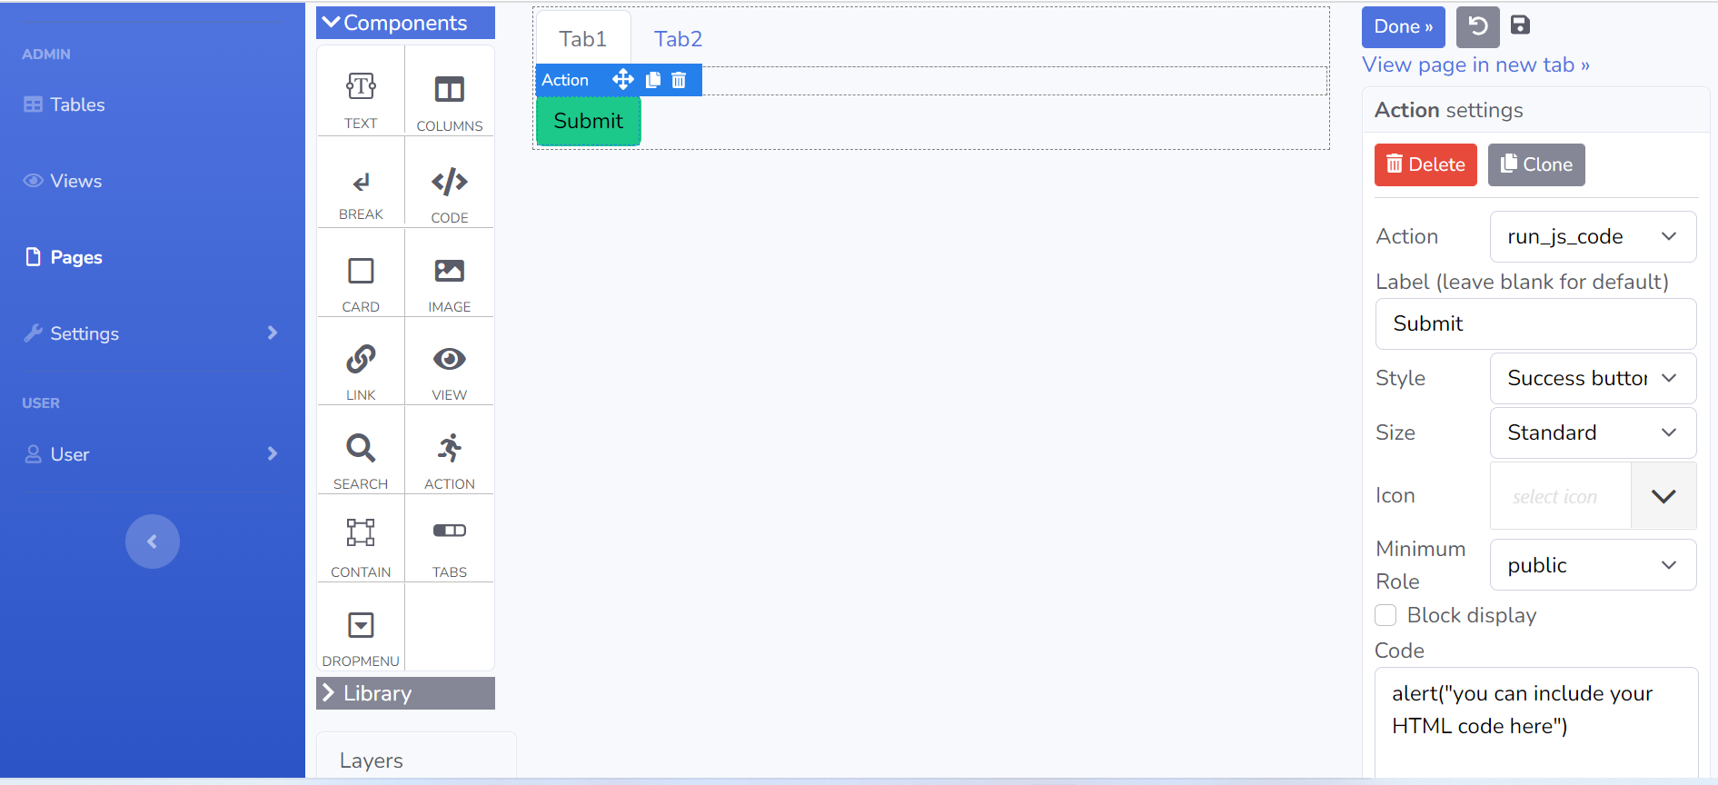

So, this is how we can design UI based on the requirement in an attractive way. One of the biggest advantages being understandability, there is no need to be a person from development front to design the UI.

There are options to add views based on the data model designed which in turn can be added to the UI. Views can be of any type like List, create, edit and so on as shown below.

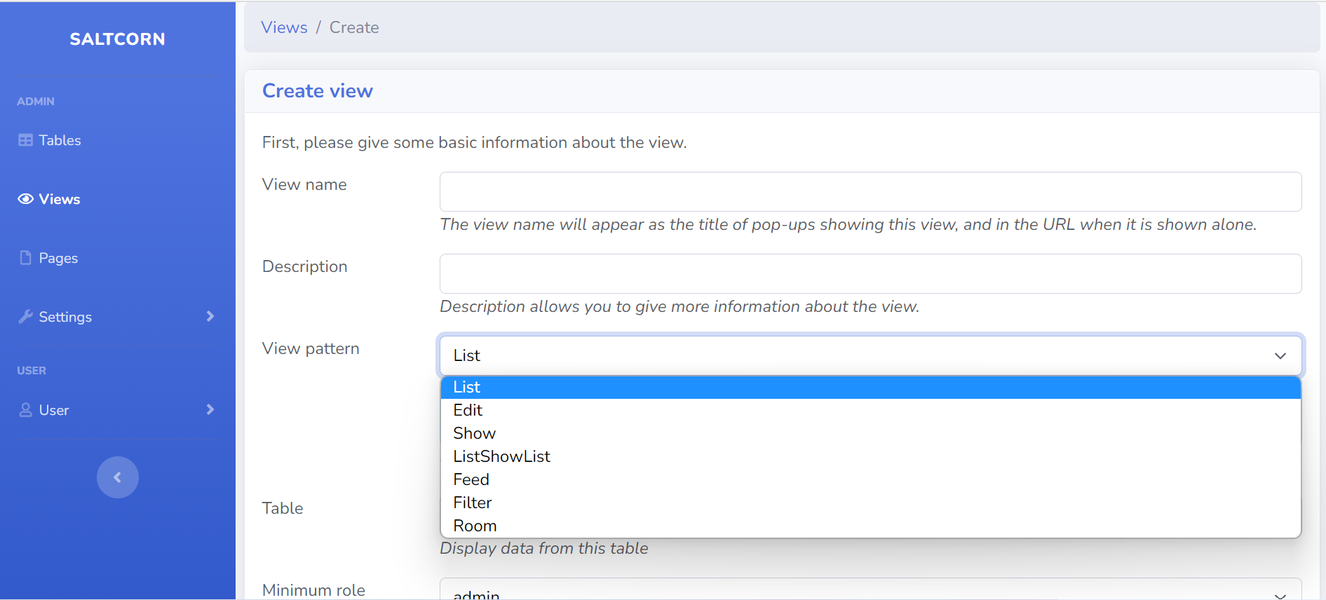

**Data-Model**

To develop any application, the basic need would be data, designing the data-model based on the requirements should be done. In this tool there I no need to write run queries or join tables.

The image below illustrates how to create table using the tool.

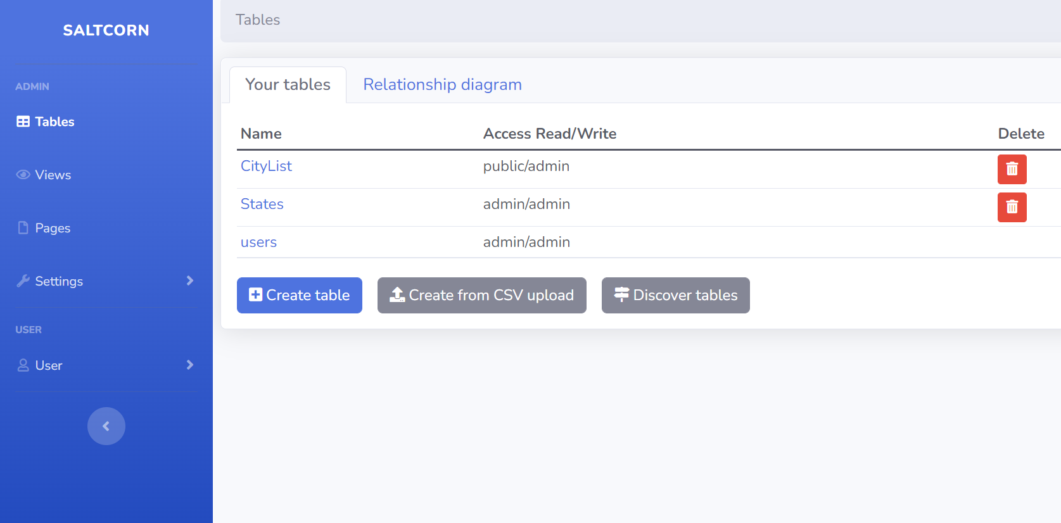

In the left pane, you can see tables section, clicking on that you see tables that already has been created and an option to create a new table. There is an option to create a new table via CSV upload too.

After creating a table, you need to add required fields to the table, so image below depicts the same

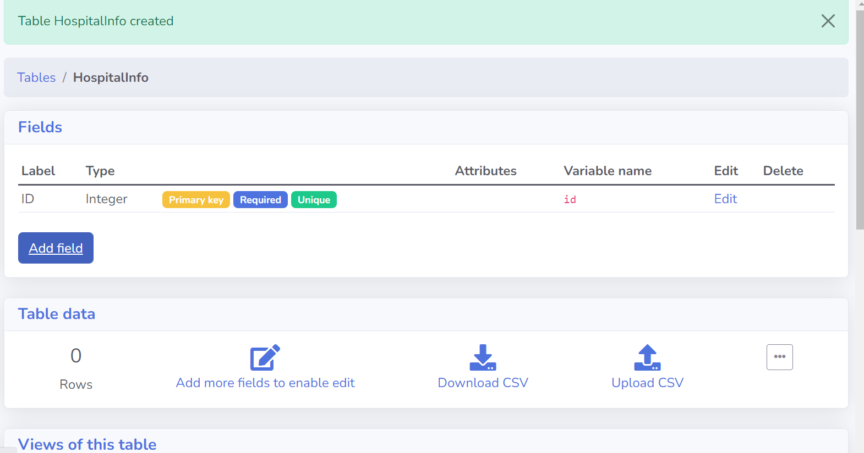

In the fig, whenever the table is created, automatically ID field will be generated. You can then decide how many fields are required and so on.

Below there is option to add data to the table or upload data via CSV which is again very easy to do with less time and effort.

Overall creating & managing the data, performing all the CRUD operations can be done through the straightforward approach and acquire a knowledge of data model design.

**Plug-ins, Triggers and Storage**

**Plug-ins**

There is an option to add plug-ins, themes and modules as shown below. Plug-ins options are like add-ons where you can make you application look very attractive, responsive and add a lot of features to it. This tool is of great use for the same.

Below figure shows the plug-ins that are made available in the Salt corn tool.

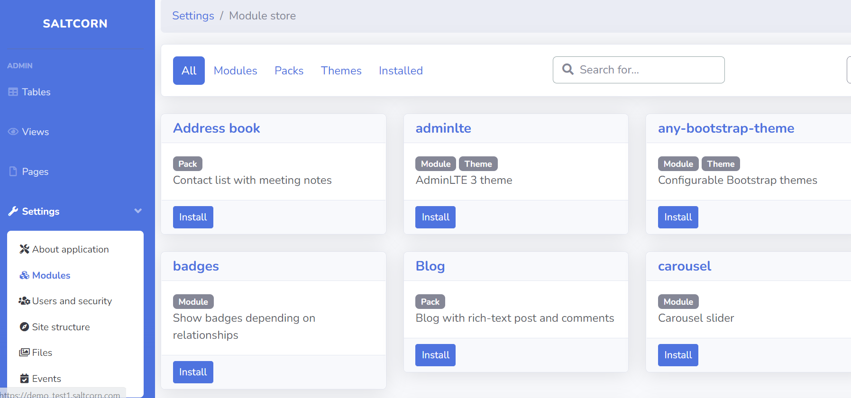

**Triggers**

In the current business trend, you see a lot of things getting automated or users would wish to do the tasks as quickly as possible.

Triggers would be helpful to automate some of the tasks, or some of the actions to take place when an event happens like, when an item or record inserted to the table, you might want to send an email to the user as an acknowledgement and so on. Below image illustrates the options available.

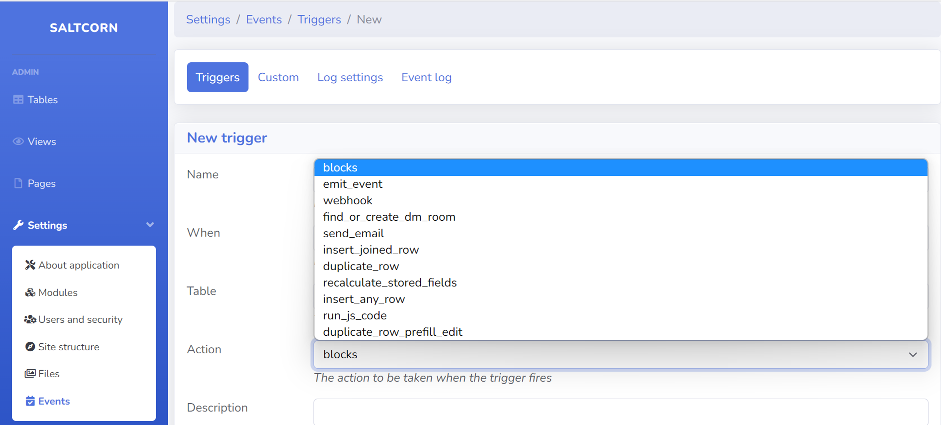

**Storage**

There is option in this file to Store your data to Amazon S3 bucket as well which creates connection securely. Below fig. depicts how to add the connection for the storage

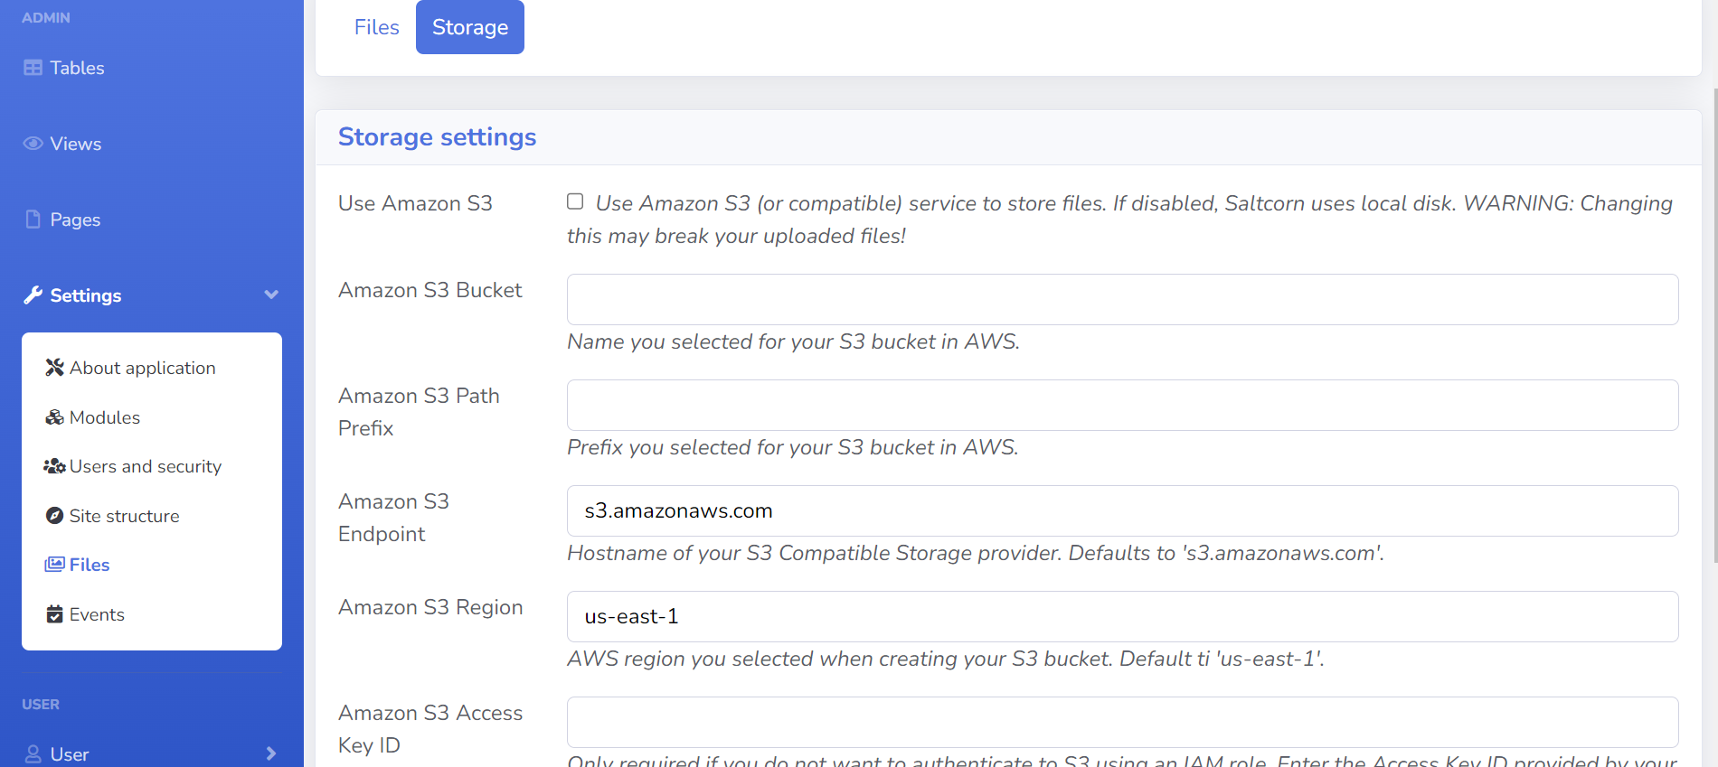

**Testing**

As this Tool provides an option to create a web application, You can test your application manually or perform an automation testing.